**Unit 73**

Communication Skills for Creative Media Industries

*Sound Manipulation – Adobe Audition 2017*



Content

Contents

Sound 1 3

Step 1 – Opening Adobe Audition 3

Step 2 – Creating a new project 4

Step 3 – Naming a project 4

Step 4 – Importing an audio file 4

Step 5 – Volume 6

Step 6 – Cropping 9

Step 7 – Fade Out and In 10

Step 8 – Pitch 12

Step 9 – Amplify 15

Step 10 – Channel Mixer 17

Step 11 – Accessing the hard limiter 19

Step 12 – How to add an echo 21

Step 13 – Automatic Pitch Correction 22

Sound 2 24

Step 1 – Deleting Ambient Sound 26

Step 2 – Adding an echo 28

Sound 3 30

Step 1 – Deleting Background Noise 31

Step 2 – Shortening the length of the file 32

Step 3 – Audio loop 34

Sound 4 35

# Sound 1

# Step 1 – Opening Adobe Audition

Open Adobe Audition 2017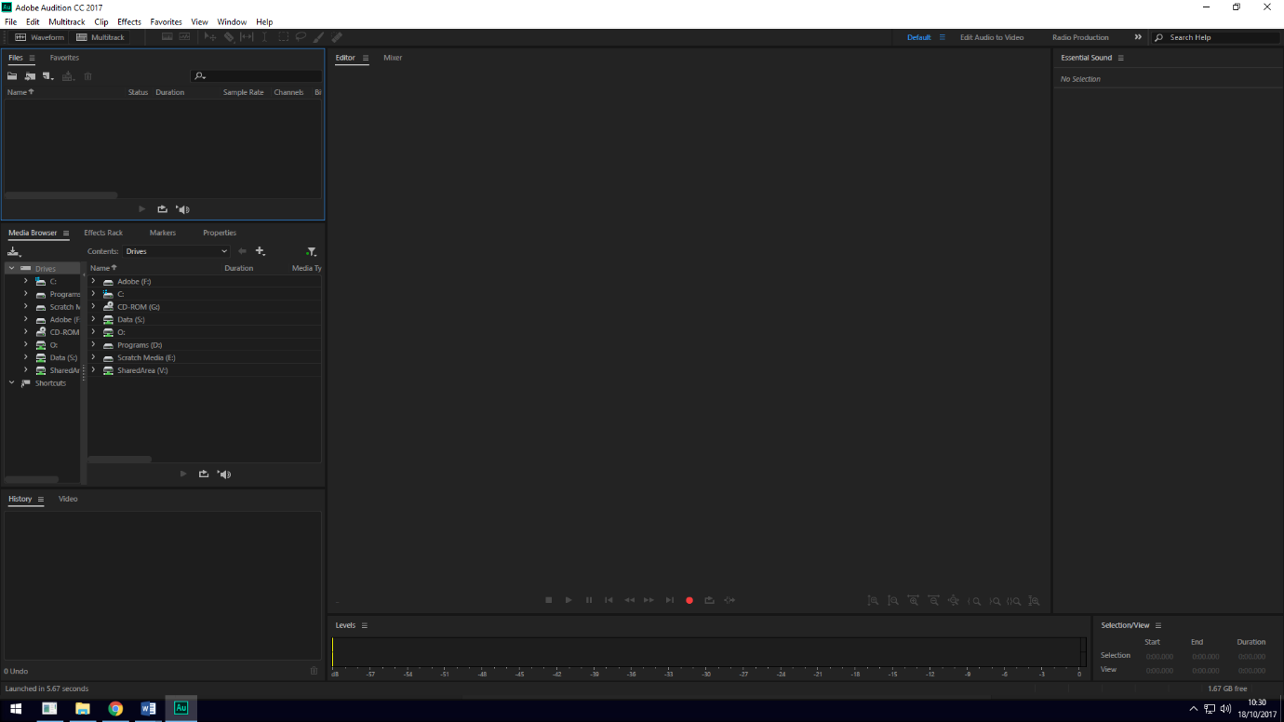

# Step 2 – Creating a new project

Create a new project by going to File, New, Audio File. Or press Ctrl+Shift+N.

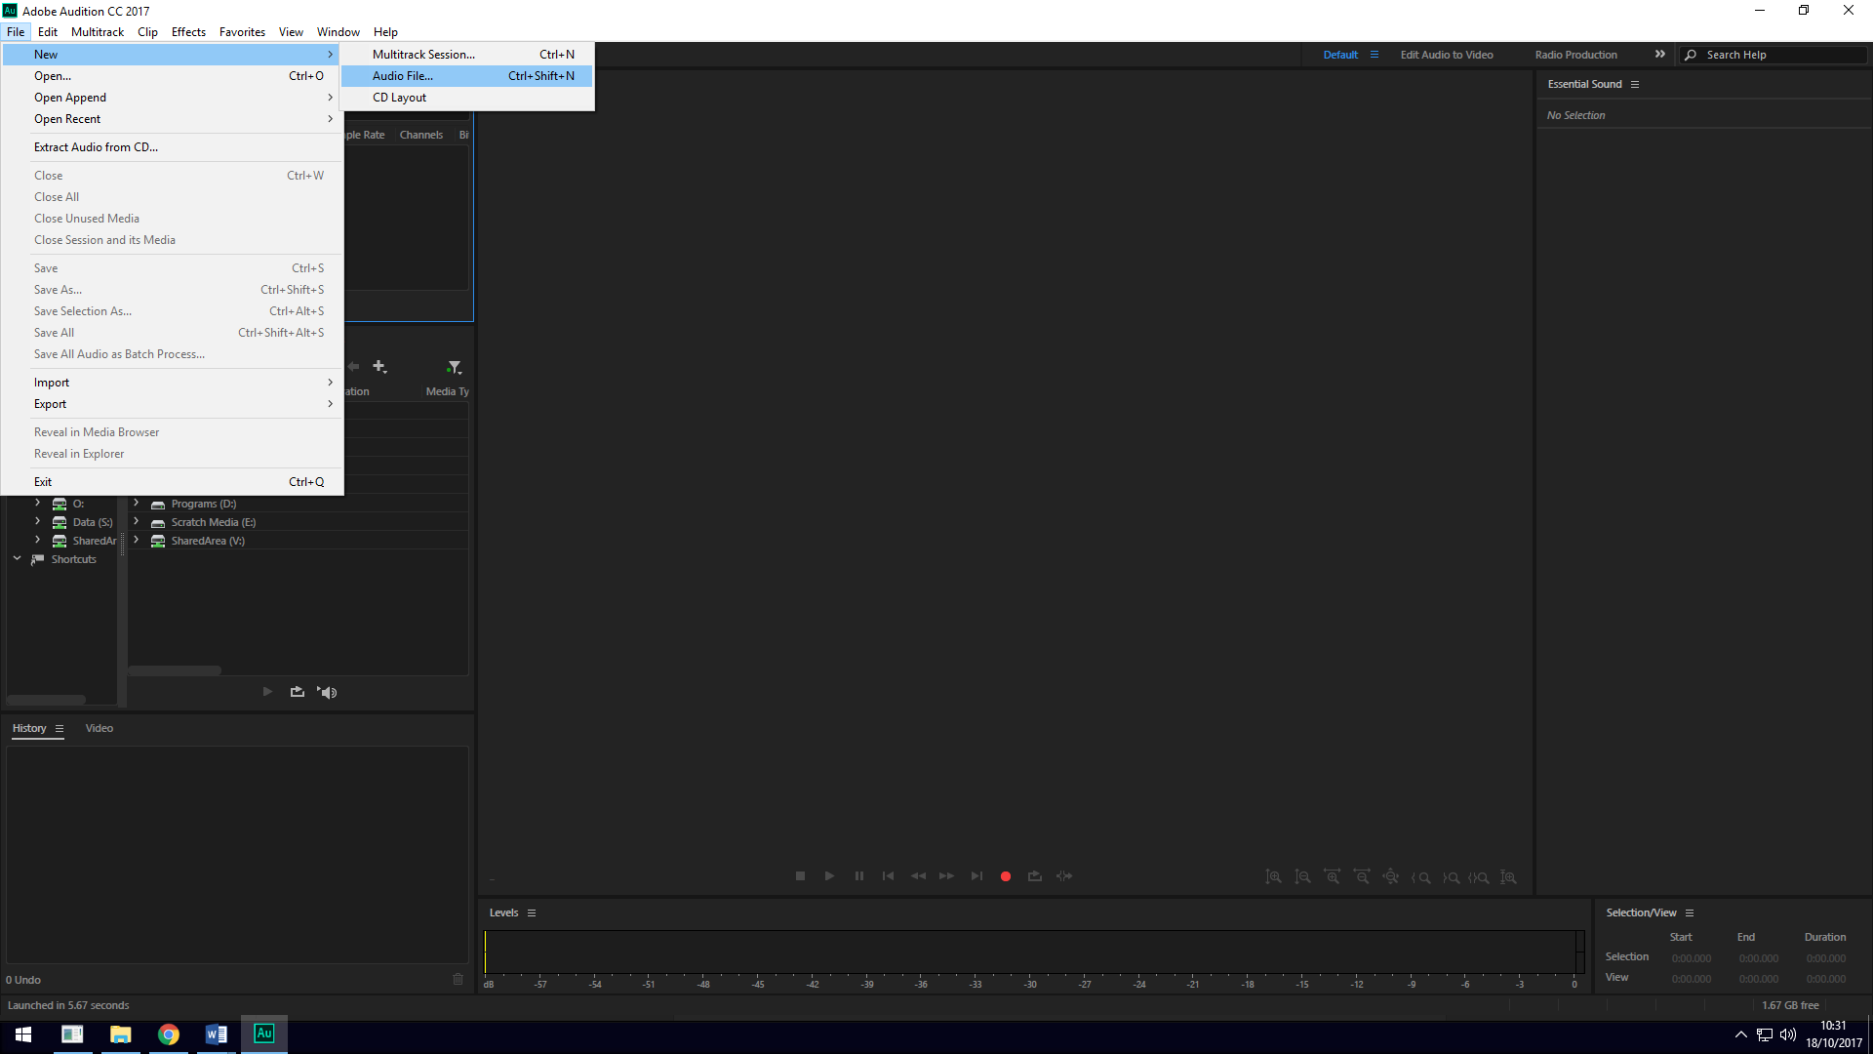

# Step 3 – Naming a project

Name the new project appropriately, and then select OK.

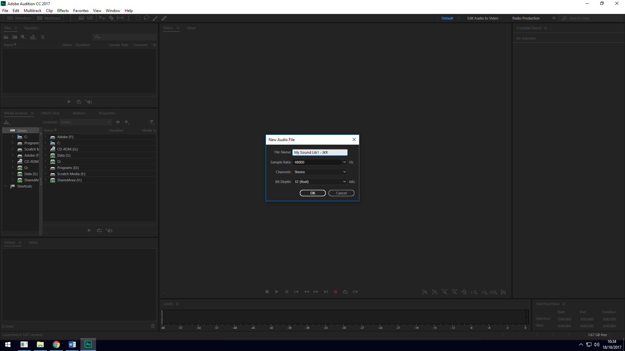

# Step 4 – Importing an audio file

Import an audio file into Adobe Audition by going to File, Import, File… then click.

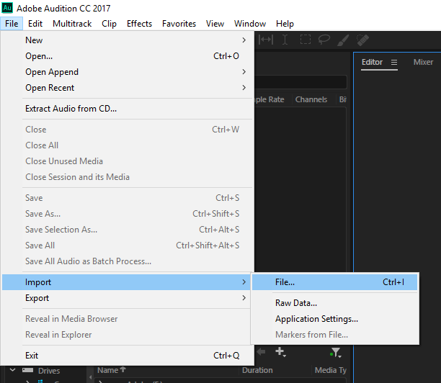

It should then look like this, then go to where the audio file is stored then click on it and open it.

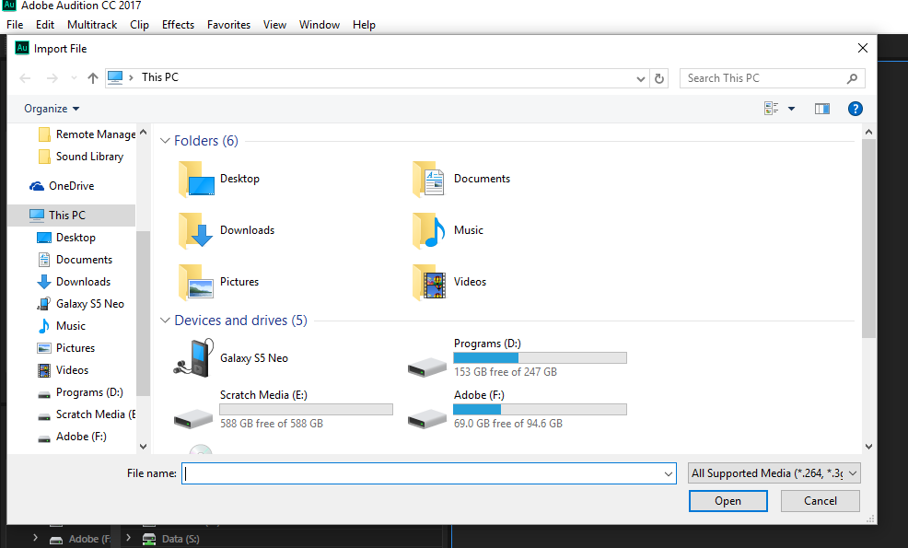



When the file is imported it will look like this.

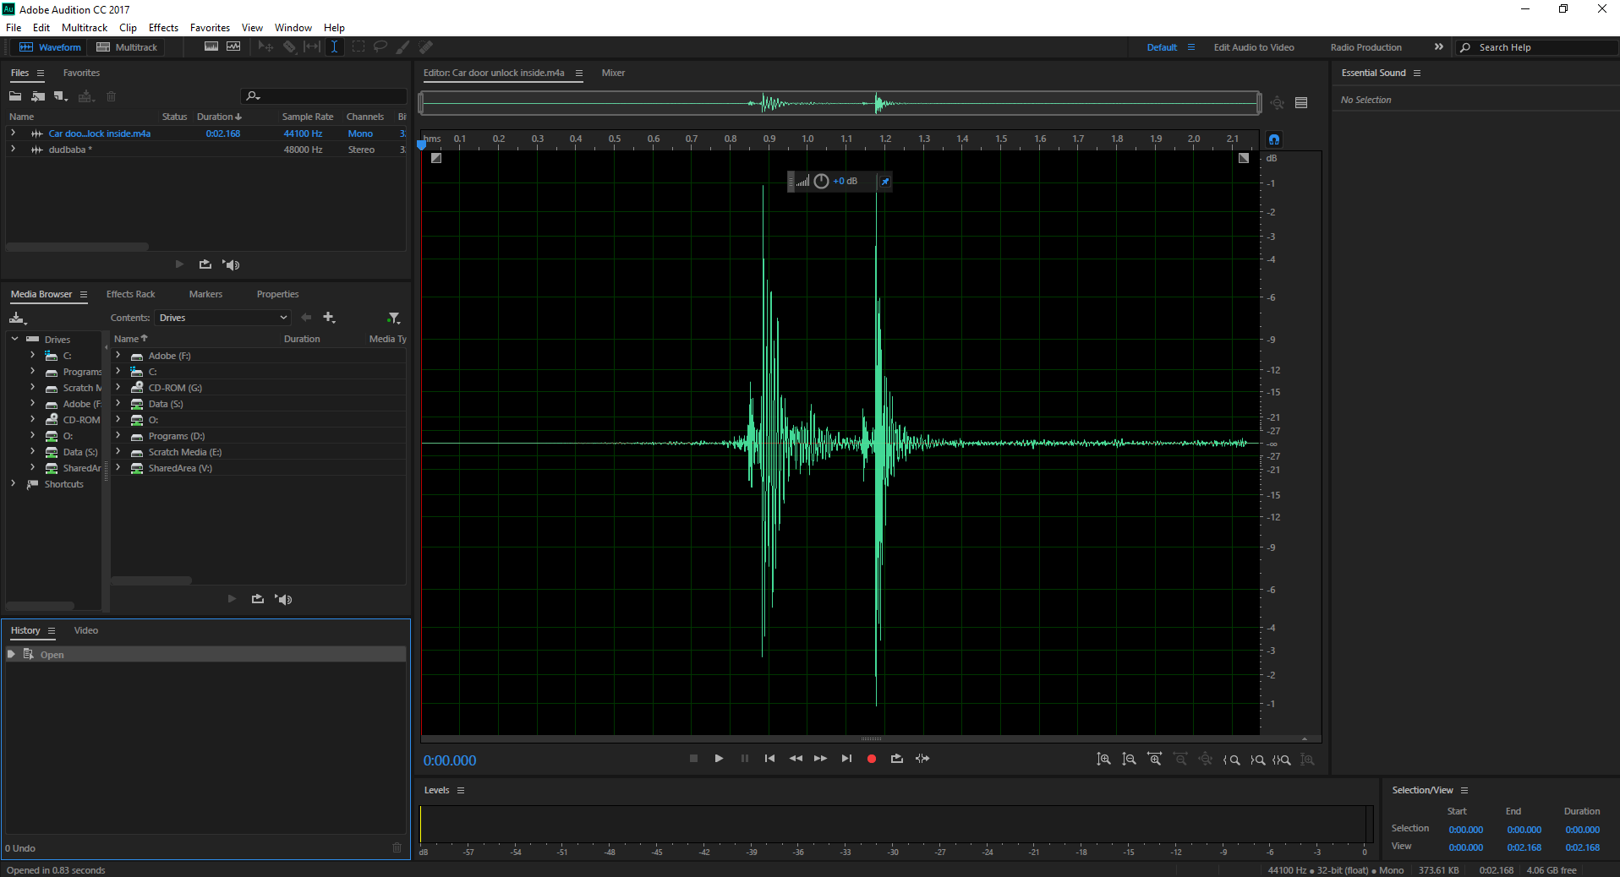

# Step 5 – Volume

To change the volume or amplitude of your file click on the circle highlighted in the picture and drag it appropriately to the to the left or right to change the sound of your file when you want to finish editing the amplitude just let go of your mouse and the file will stay at the same amplitude you edited it to.

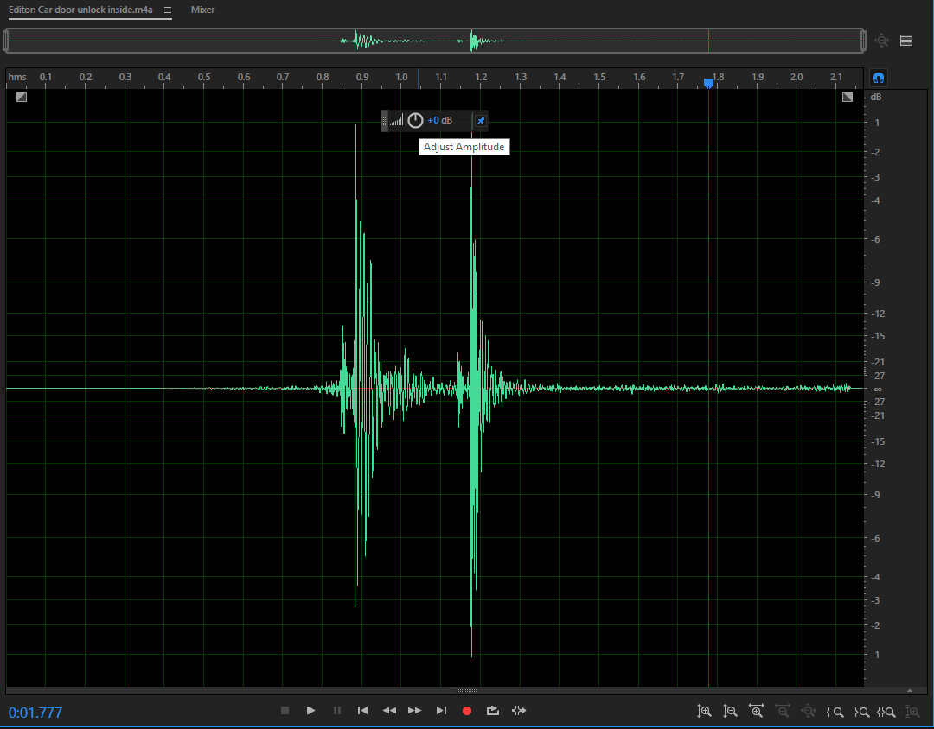

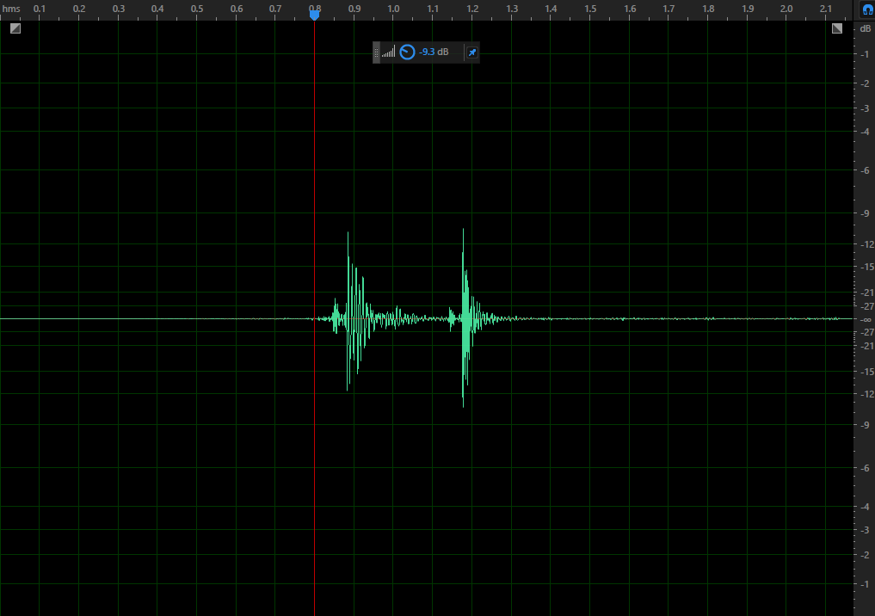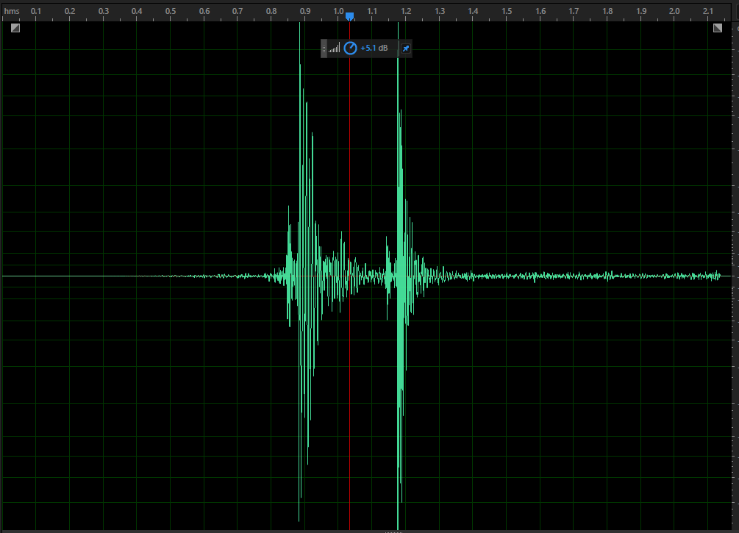

# Step 6 – Cropping

To delete unnecessary sound out of your audio file such as wind or silence just click and highlight the unwanted sound then press Ctrl and X or the delete key to delete that bit of audio.

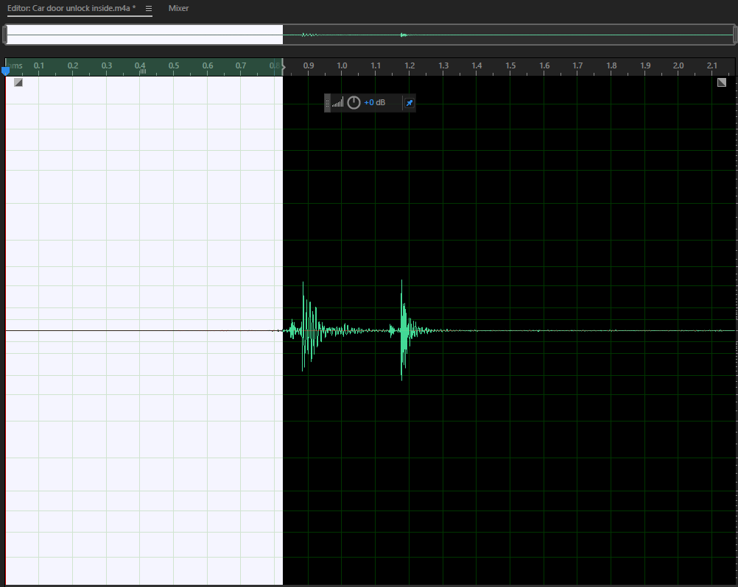

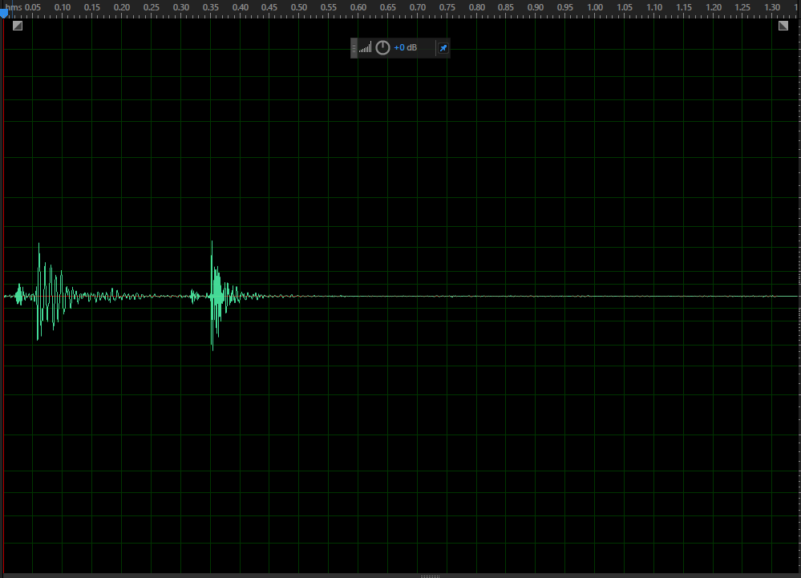

# Step 7 – Fade Out and In

To make the sound you are editing slowly rise or fall in sound you can use the fade tool. To access the fade tool go to the top right or left corner of the sound file then click and drag to the left or right. Once you want to stop just let go of your mouse and the change will stay.

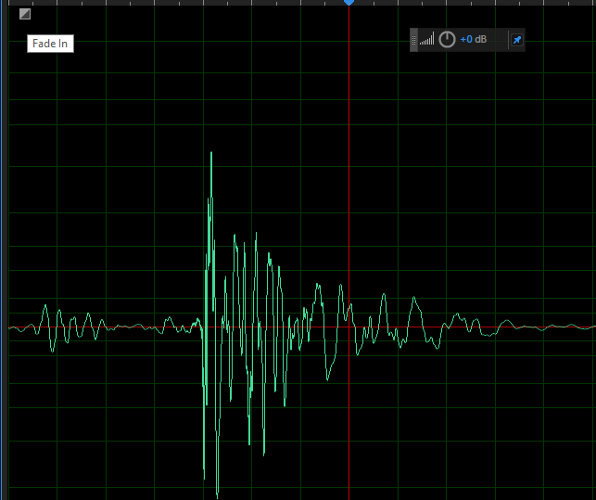

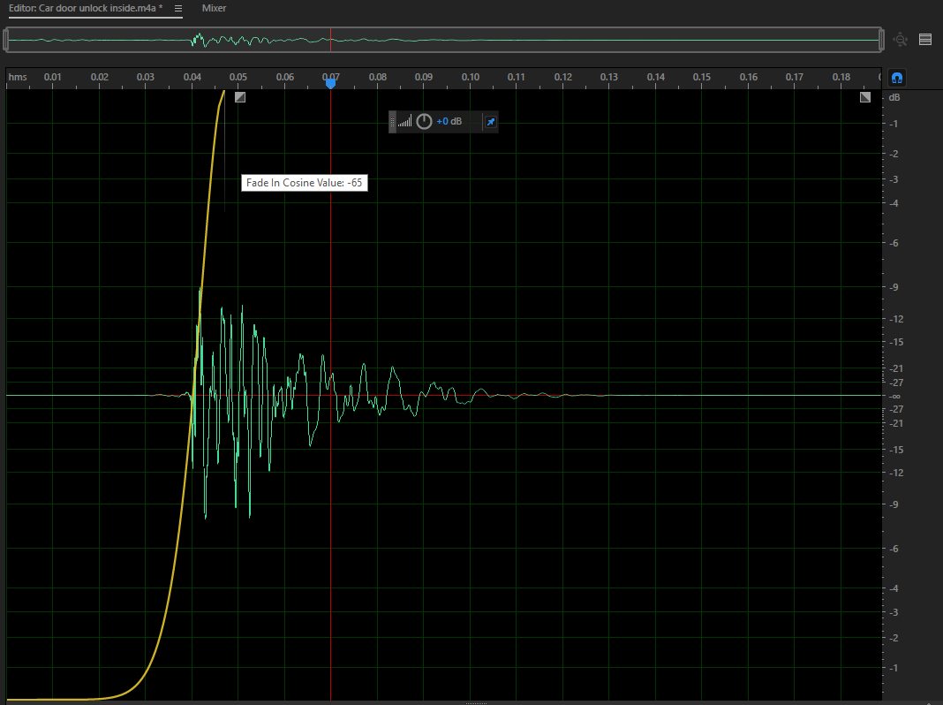

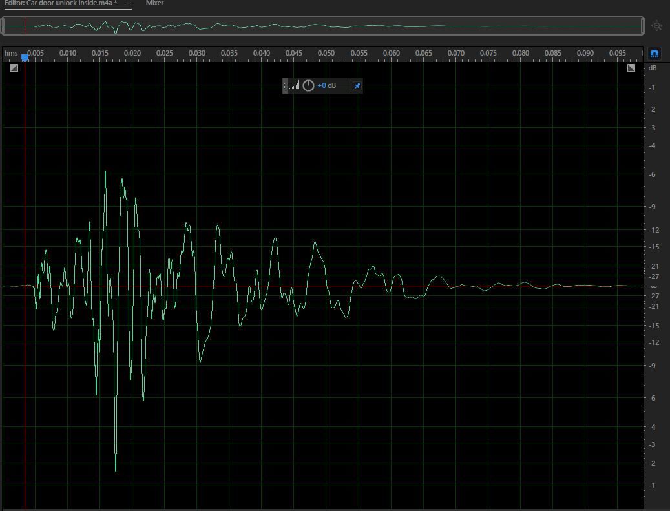

# Step 8 – Pitch

To raise and lower the pitch of you audio file go to “Favourites” and then go to “Lower Pitch” or “Raise Pitch”.

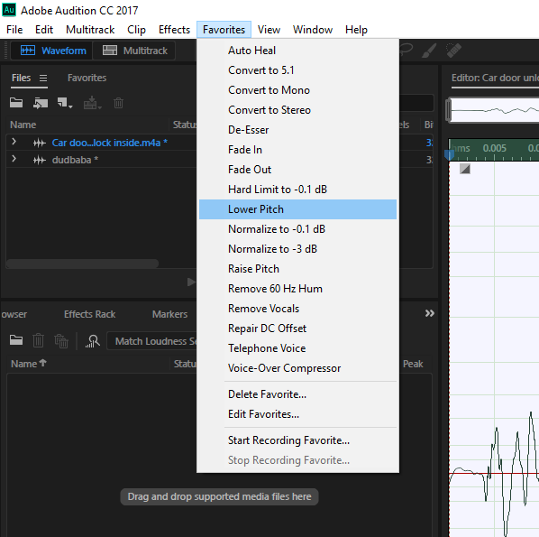

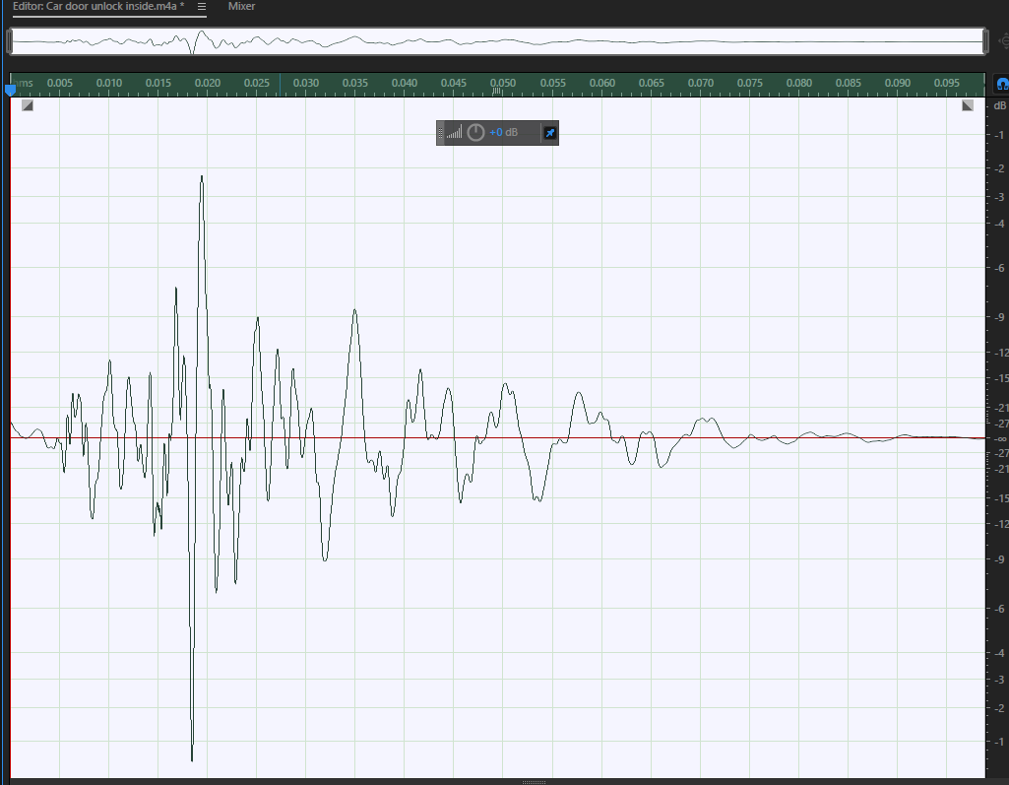

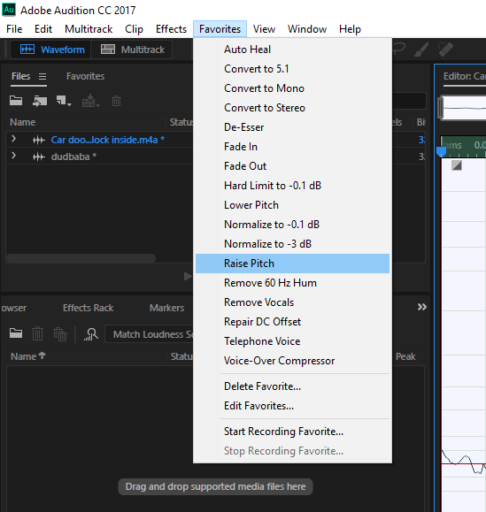

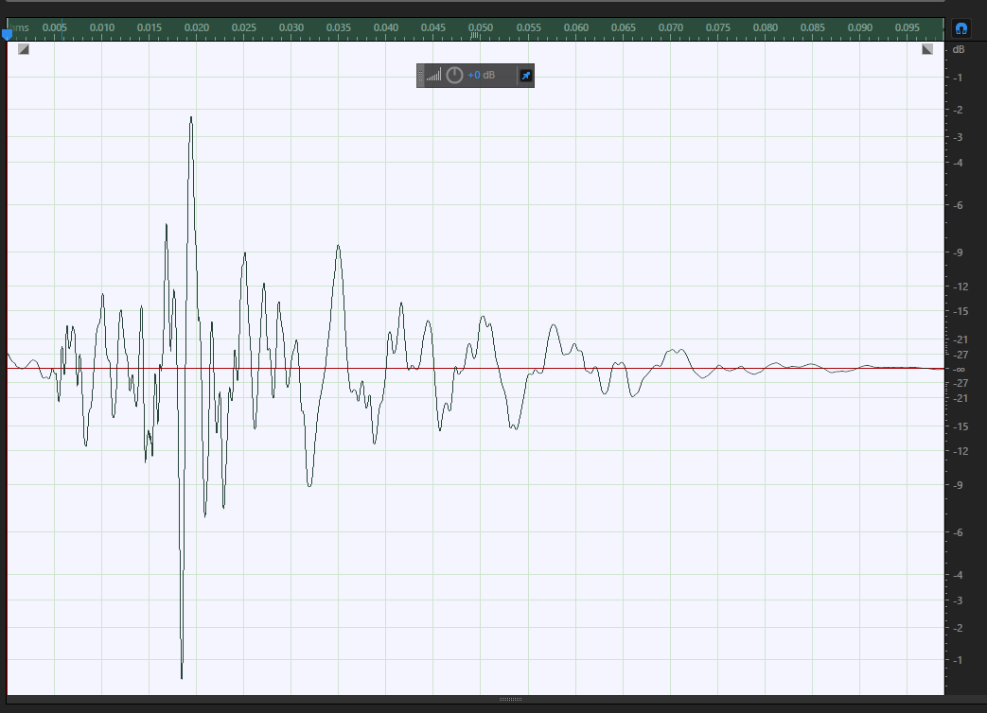

# Step 9 – Amplify

Just go to “Effects” then “Amplitude and Compression” and finally click “Amplify”, a pop up bar will show when it does just click and drag the slider to change the decibel (dB) level to make it louder or more quiet then once you are done click apply.

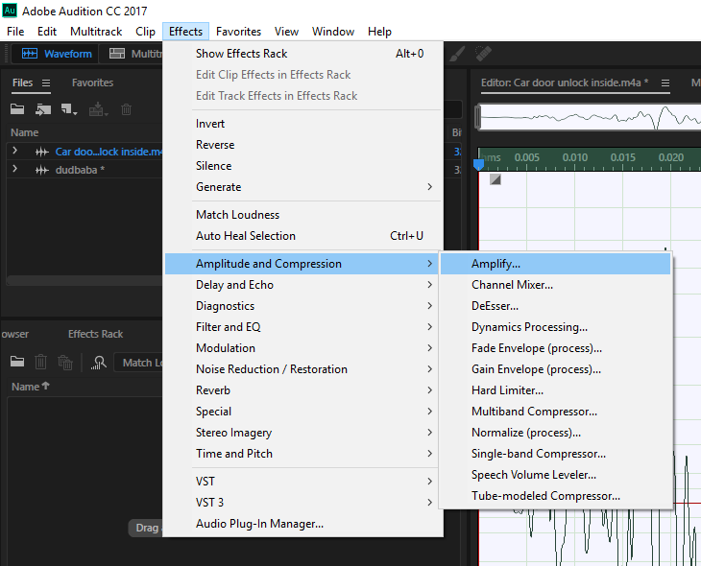

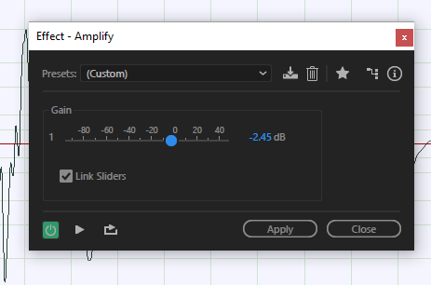

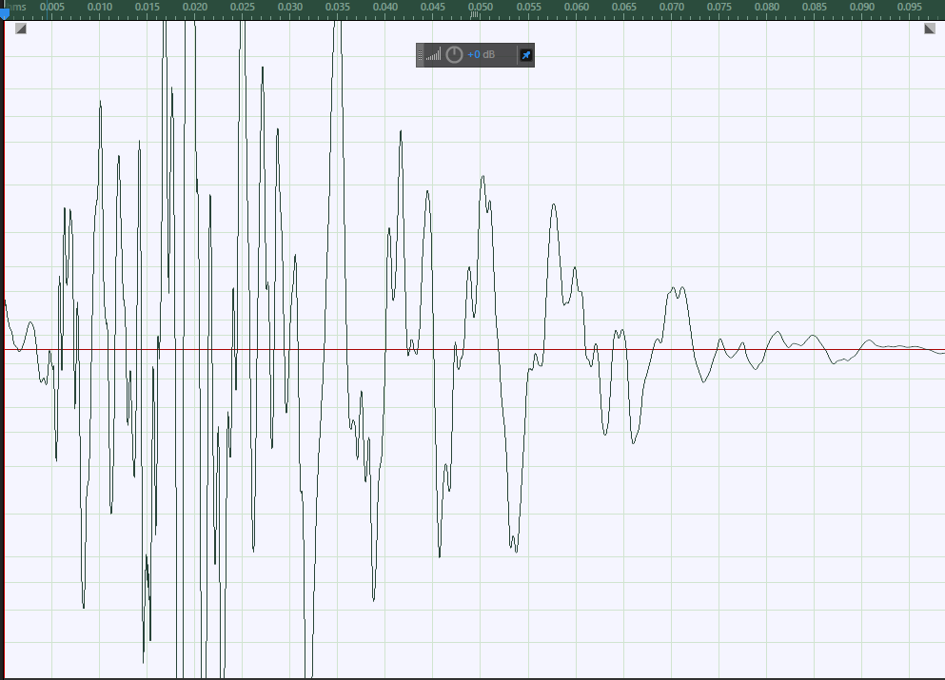

# Step 10 – Channel Mixer

To go to the channel mixer you just click “Effects”, “Amplitude and Compression” and then click “Channel Mixer” a pop up will than show and you can drag the slider to change which ear will hear the sound once you are finished click “Apply”.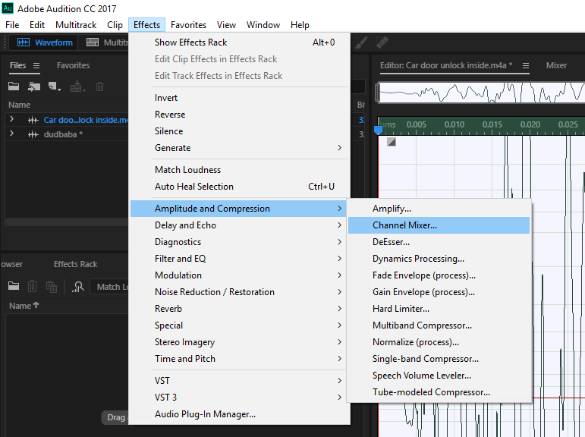

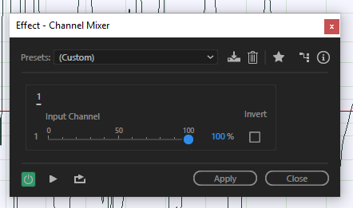

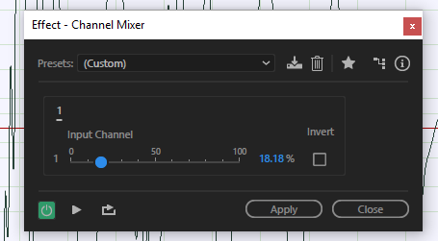

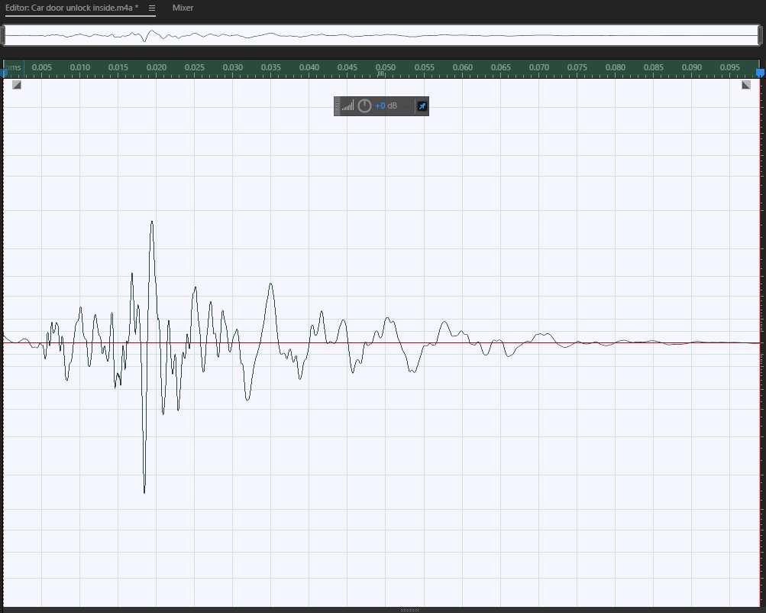

# Step 11 – Accessing the hard limiter

To go to the hard limiter pop up click on “Effects”, “Amplitude and Compression” and then click “Hard Limiter…” and the pop up will show. In the pop up you can change various thing such as the maximum amount of amplitude your sound file can reach when played.

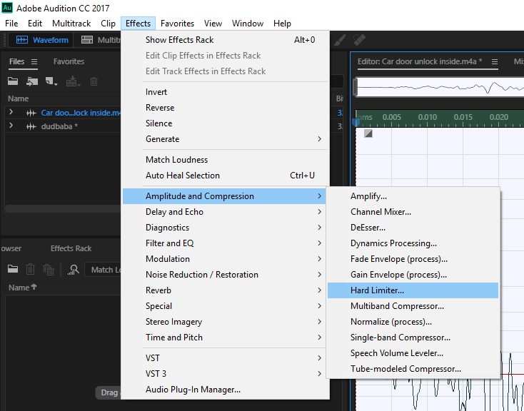

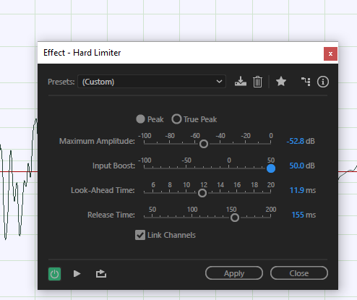

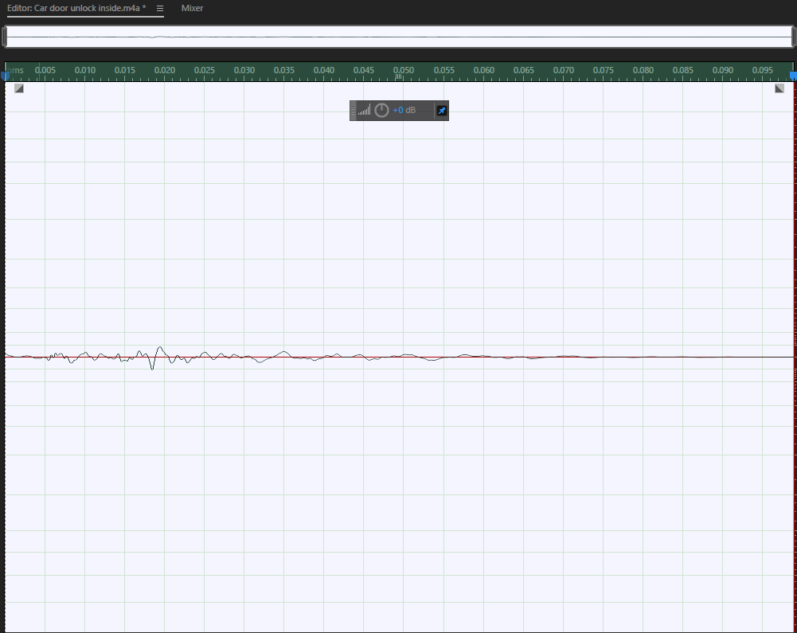

# Step 12 – How to add an echo

To make it so you can add an echo effect to your sound file go to “Effects” then “Delay and Echo” then click “Echo”. This will open a separate tab and in this tab you can drag the sliders to add different effects to the echo.

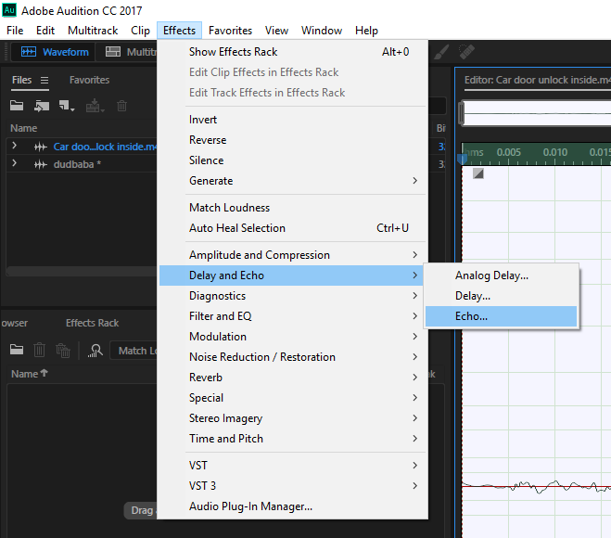

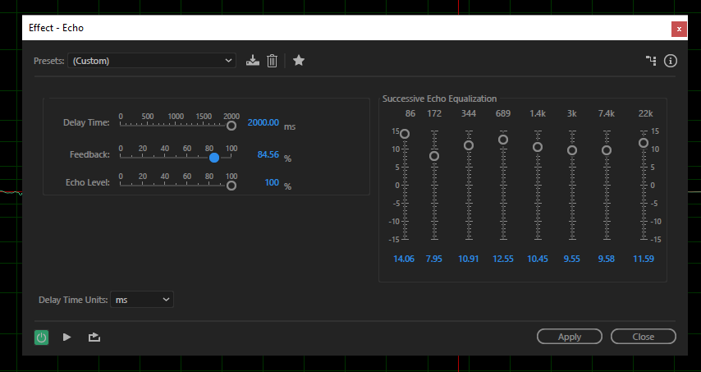

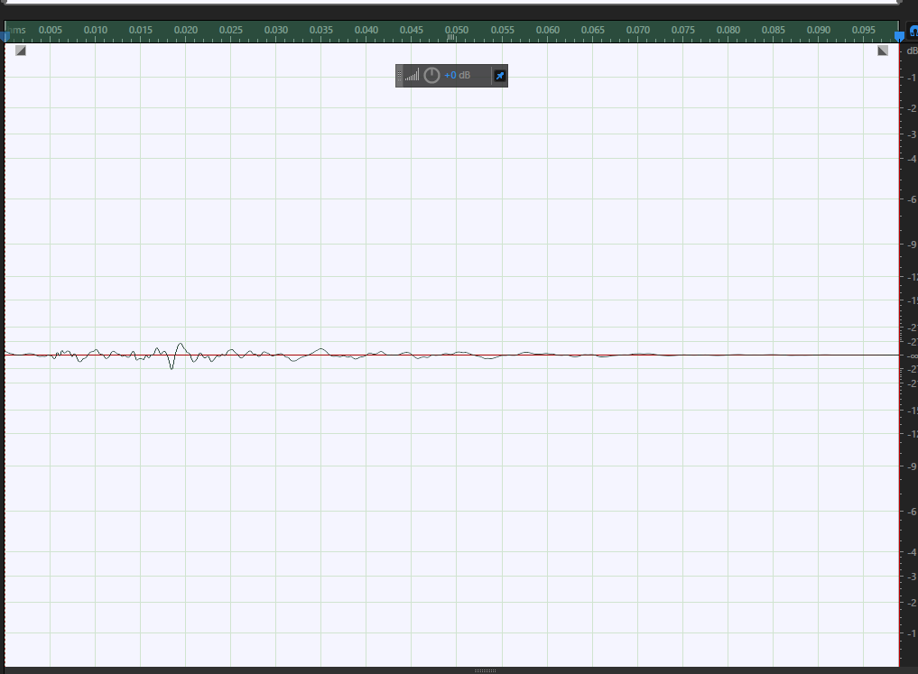

# Step 13 – Automatic Pitch Correction

To change the pitch with detail, go to “Effects”, “Time and Pitch” and then click “Automatic Pitch Correction…” a pop up bar will then show where you can drag the sliders to increase the pitch at the start of the sound file to which increases the attack (the sound file will be louder at the beginning of the file) and other things as well.

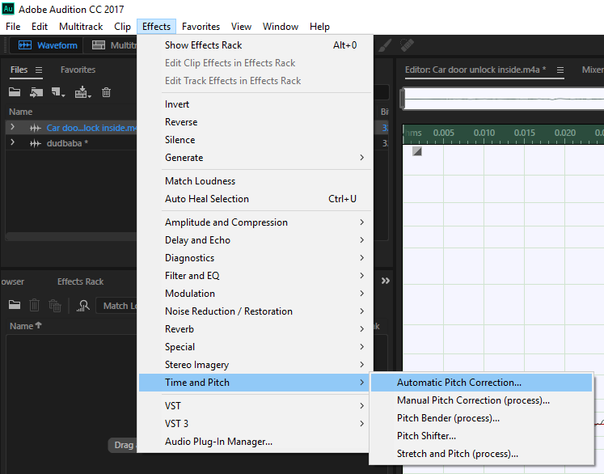

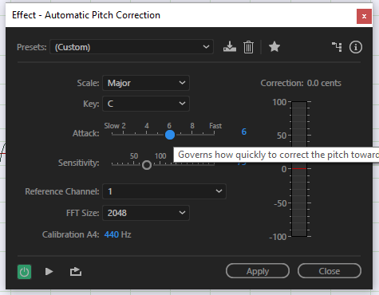

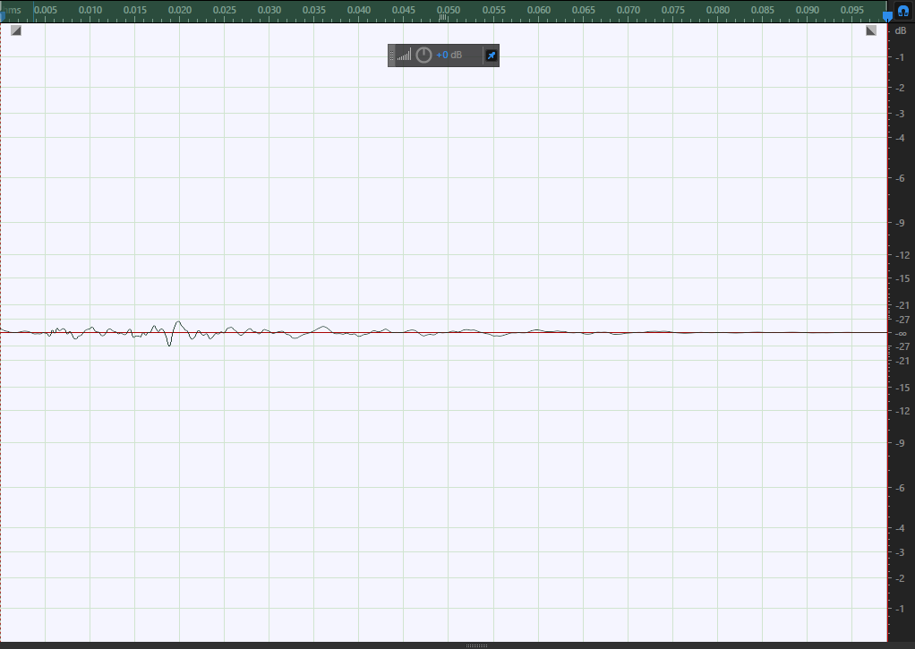

# Sound 2

This sound is meant to sound like a bone braking but it is actually a match being struck. To make it sound like a bone breaking I will need to delete the unnecessary sound in the background and add an echo.

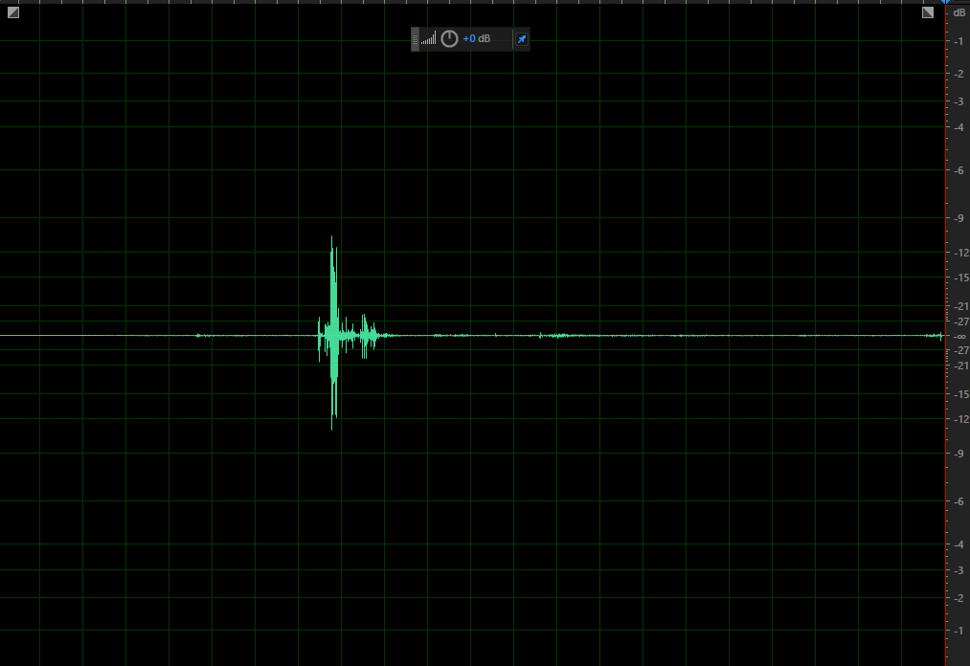

# Step 1 – Deleting Ambient Sound

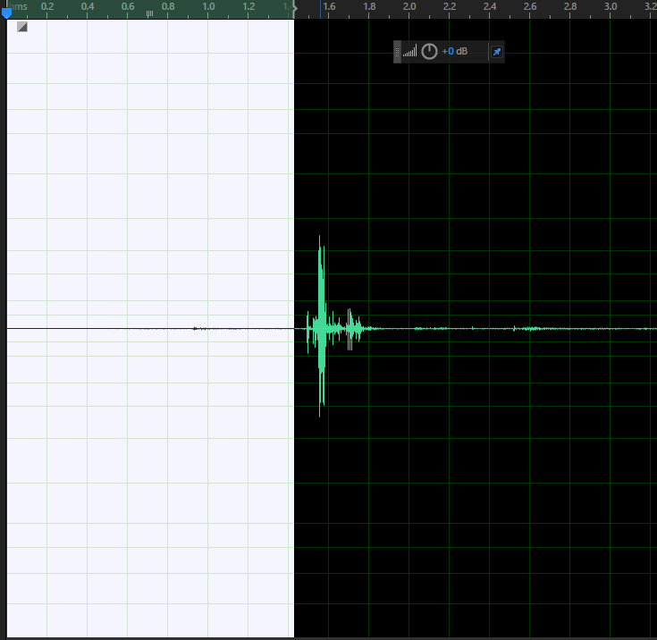

Now I’m going to press backspace and delete the ambient sound.

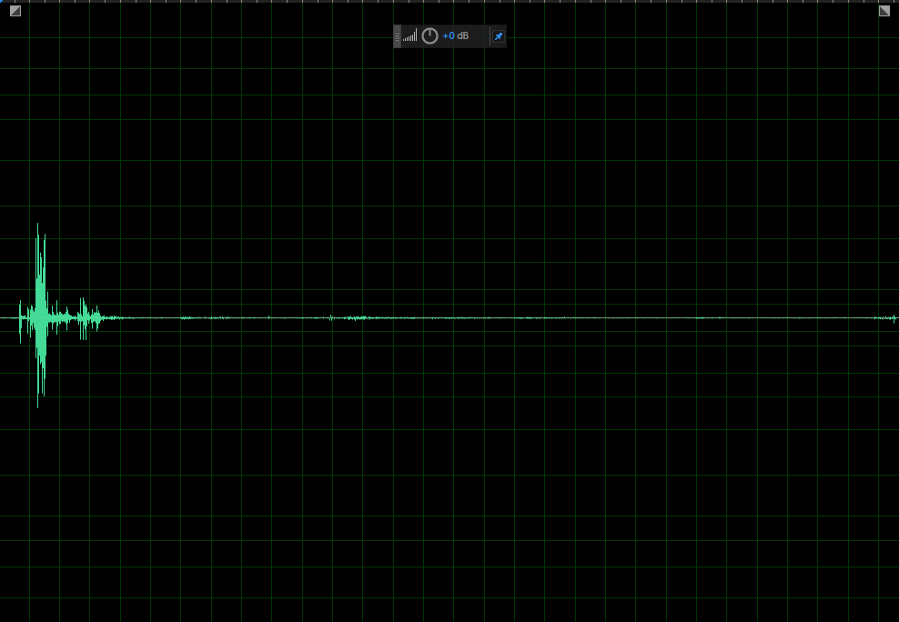

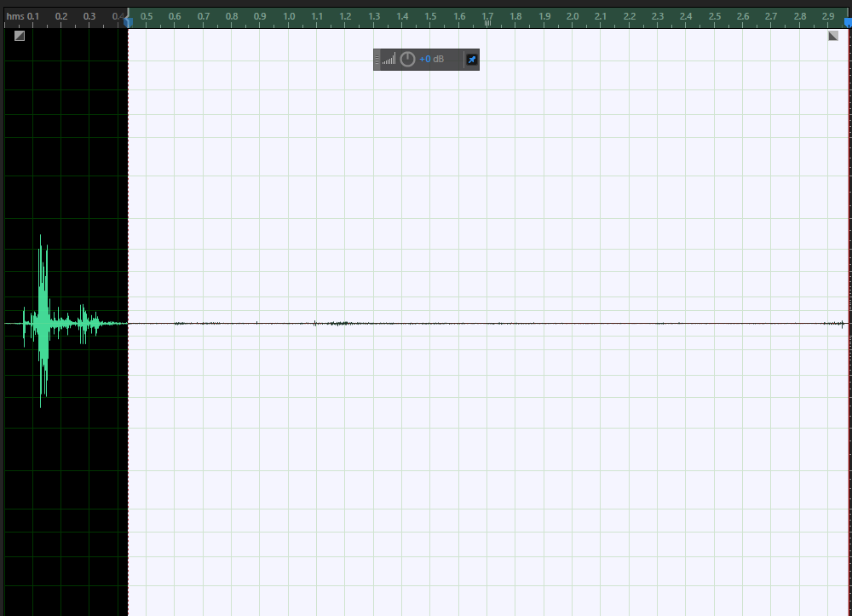

This is now my sound without the ambient sound.

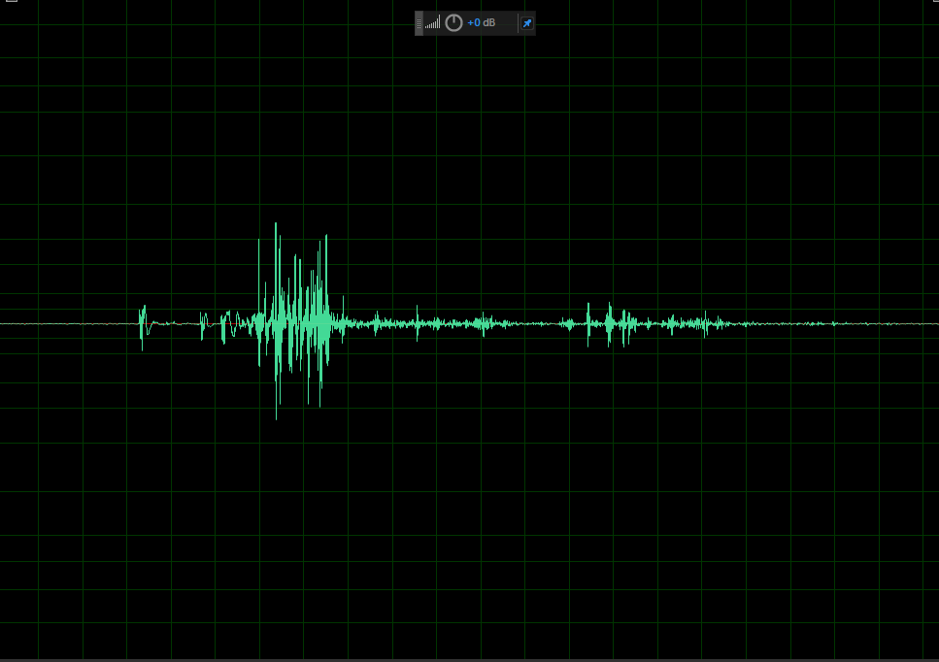

# Step 2 – Adding an echo

Now I need to add a bit of an echo to make it sound more realistic. I did this by going to “effects” then “delay and echo” then “echo…” and I clicked on echo. After that this pop up displayed and I put the echo level up. Then I pressed apply and my sound now had a bit of an echo and was the sound I wanted.

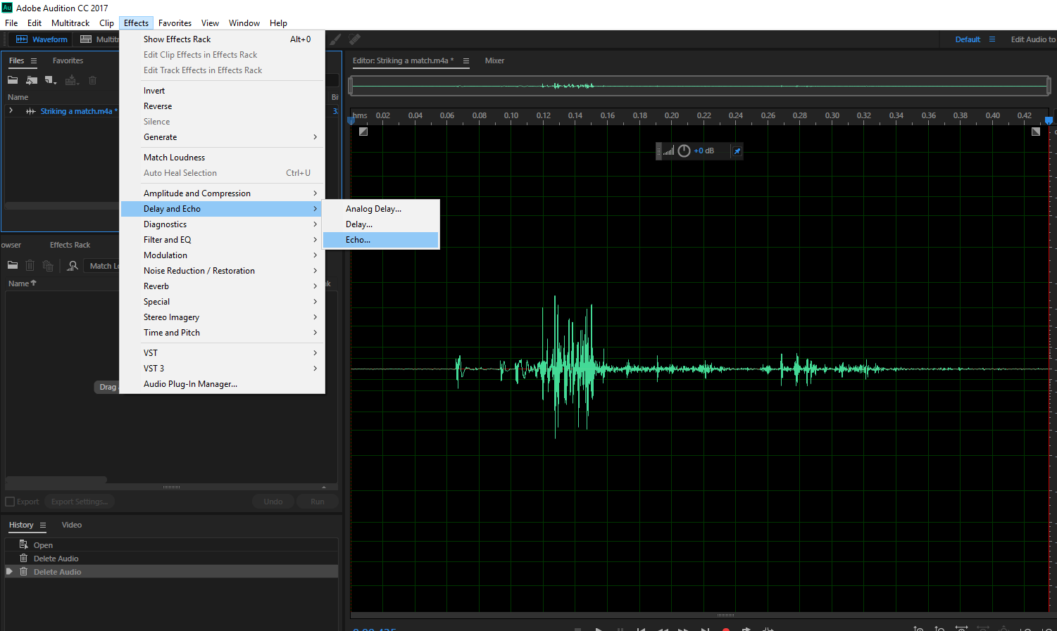

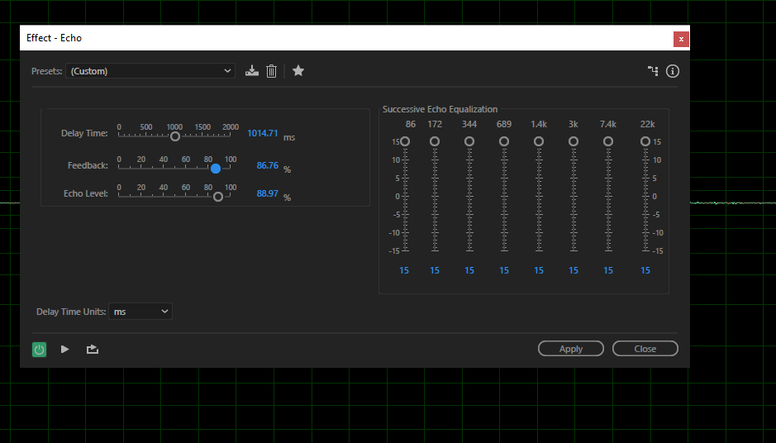

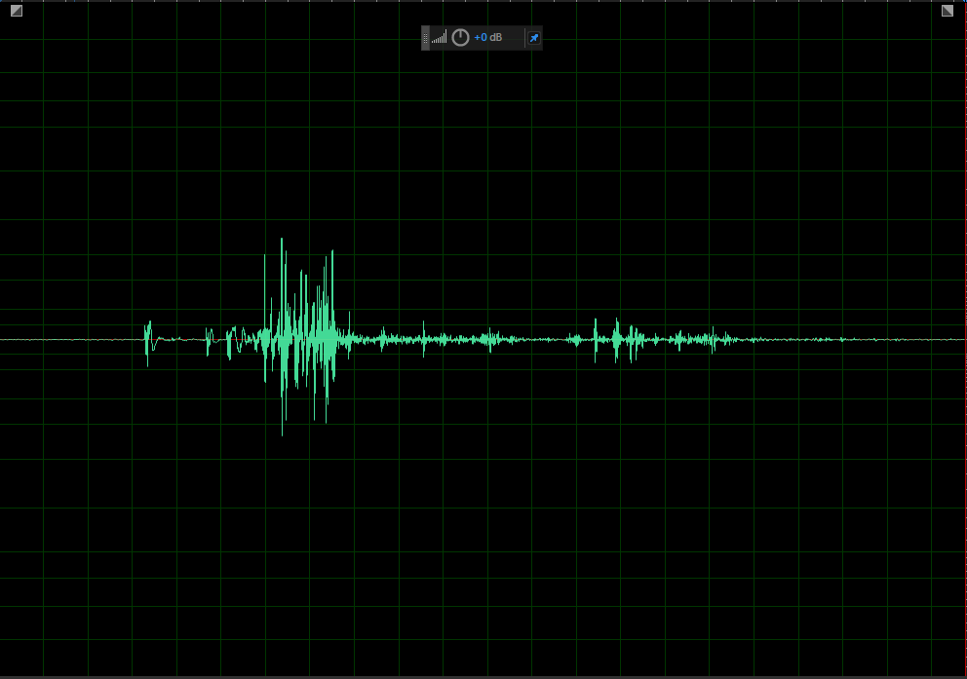

# Sound 3

This sound is meant to be gunfire but I used Foley artistry and recorded myself breaking a stick. To change this into gunfire I am firstly going to delete any ambient sounds.

# Step 1 – Deleting Background Noise

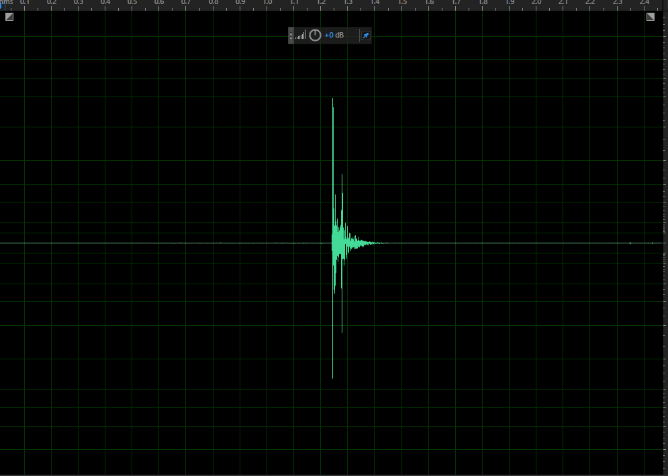

This is after I got rid of the background noise.

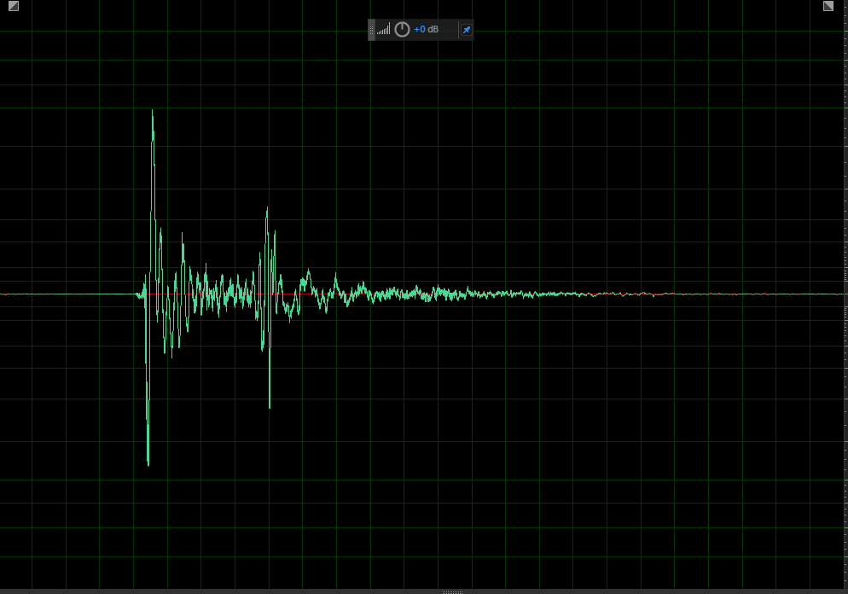

# Step 2 – Shortening the length of the file

Now I need to make it so when I put the sound on a loop so if an automatic rifle is shot it will be faster and sound like an actual gun. To do this I will go to effects then time and pitch and then click on Stretch and Pitch. Once that is click a separate tab will open. With this tab I went to the stretch bar and made it go all the way to the left. Then press apply.

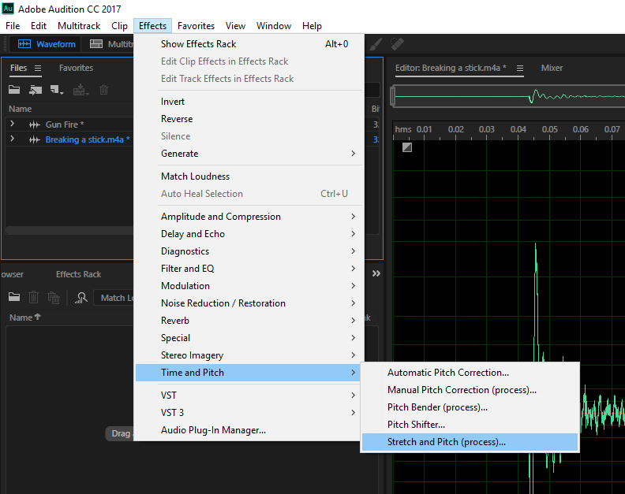

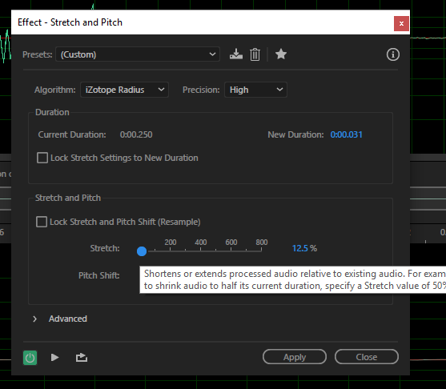

Then go back to the tab press advanced and more of the tab will show. Then change pitch coherence to 4 and press apply then the sound I made sounded like an automatic rifle.

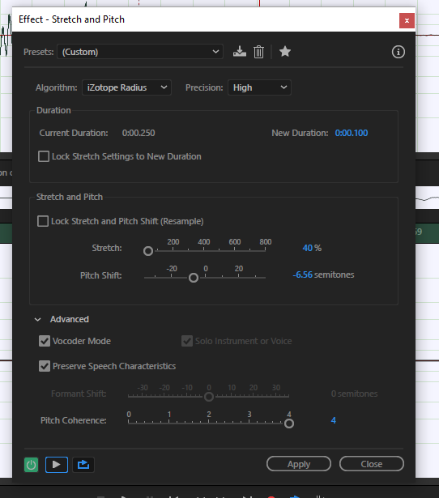

# Step 3 – Audio loop

To make your sound loop just go to the bottom bar and click the Loop Playback button highlighted blue.

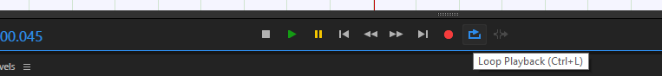

# Sound 4

This sound is meant to sound like someone is walking, to make this sound I just recorded myself walking. I am going to use this sound for when a character walks in a game I am going to make. All I’m going to do with this sound is cropping the ambient sound out.

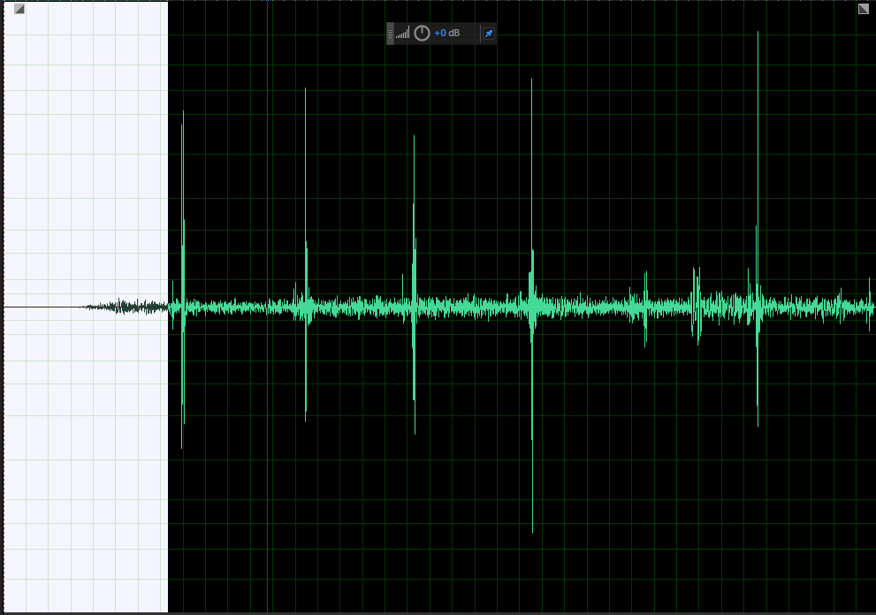

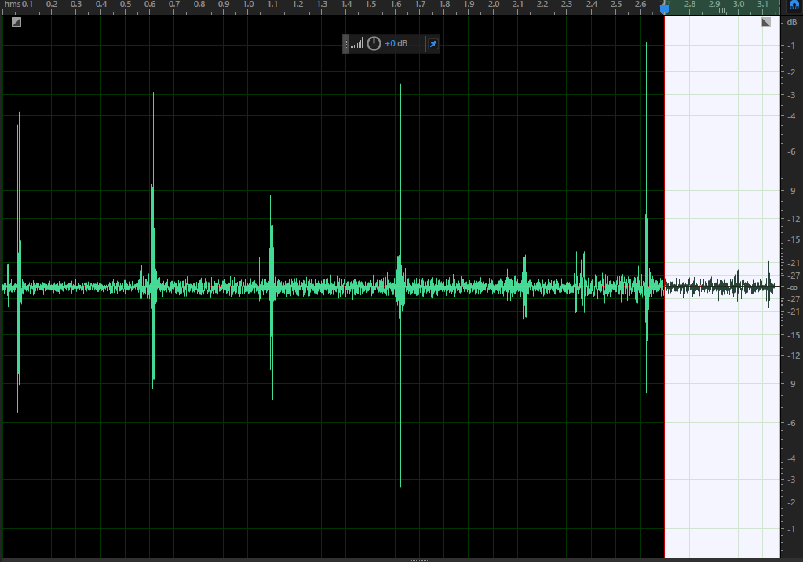

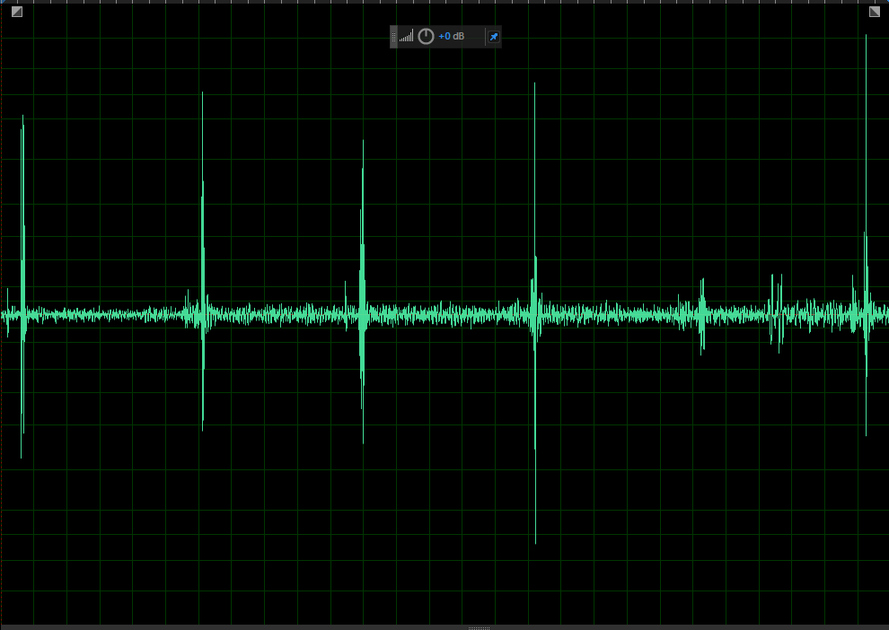

But then I decided to undo what I did by pressing CTRL and Z, I did this as when I put the sound on a loop it did not sound realistic so after that I just cropped the opening sound out where it was just silent. This is the end result.

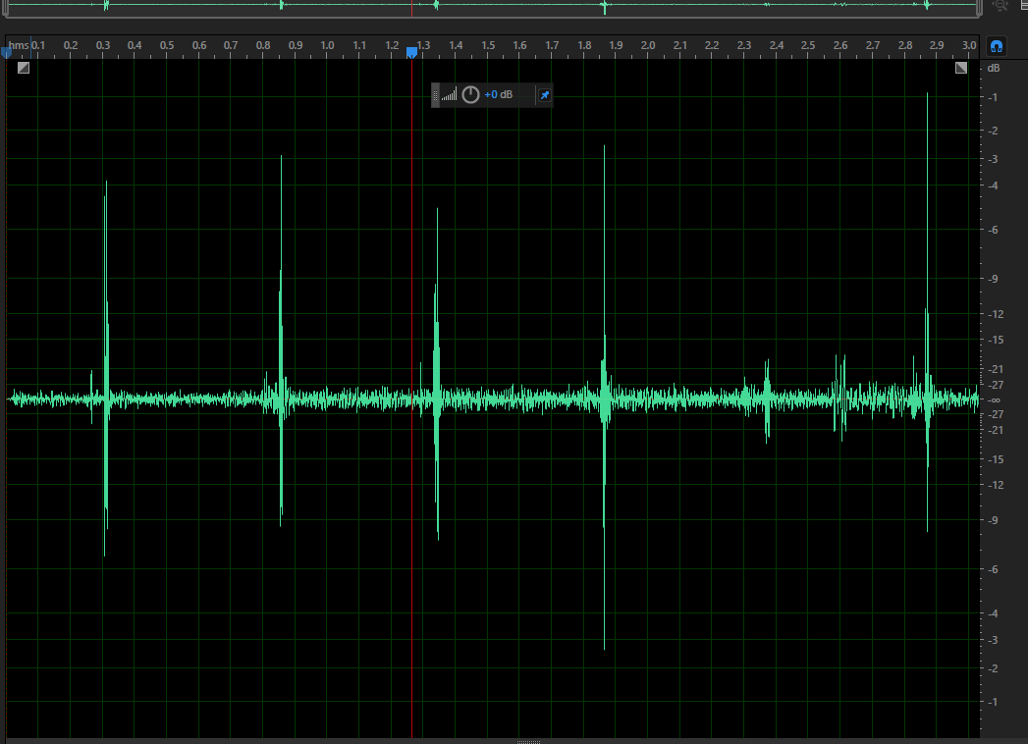

Another way to create sounds is too use this website: <https://www.bfxr.net/> you do this by adjusting the handlers of the online software.